**Website URL**

**Staging** : [http://13.55.208.143](http://13.55.208.143/)

**Live** : <https://cavesroadolives.com.au>

**How to manage Offer Popup**

**To manage the content of the offer popup that has been customized through a customizer, follow the steps below:**

**1.)** Log in to your dashboard.

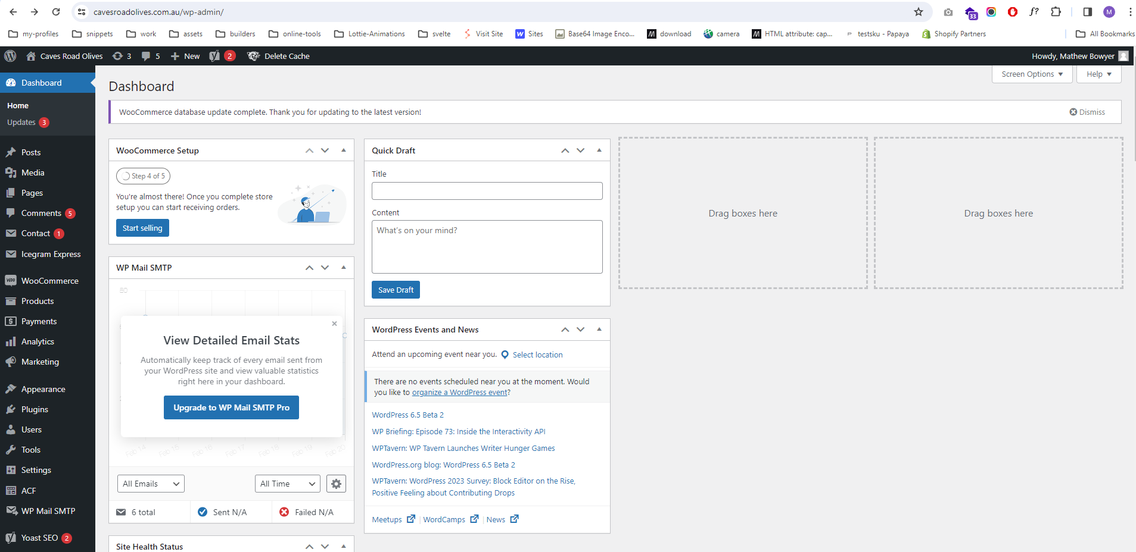

**2.)** Navigate to the "**Customizer**" section.

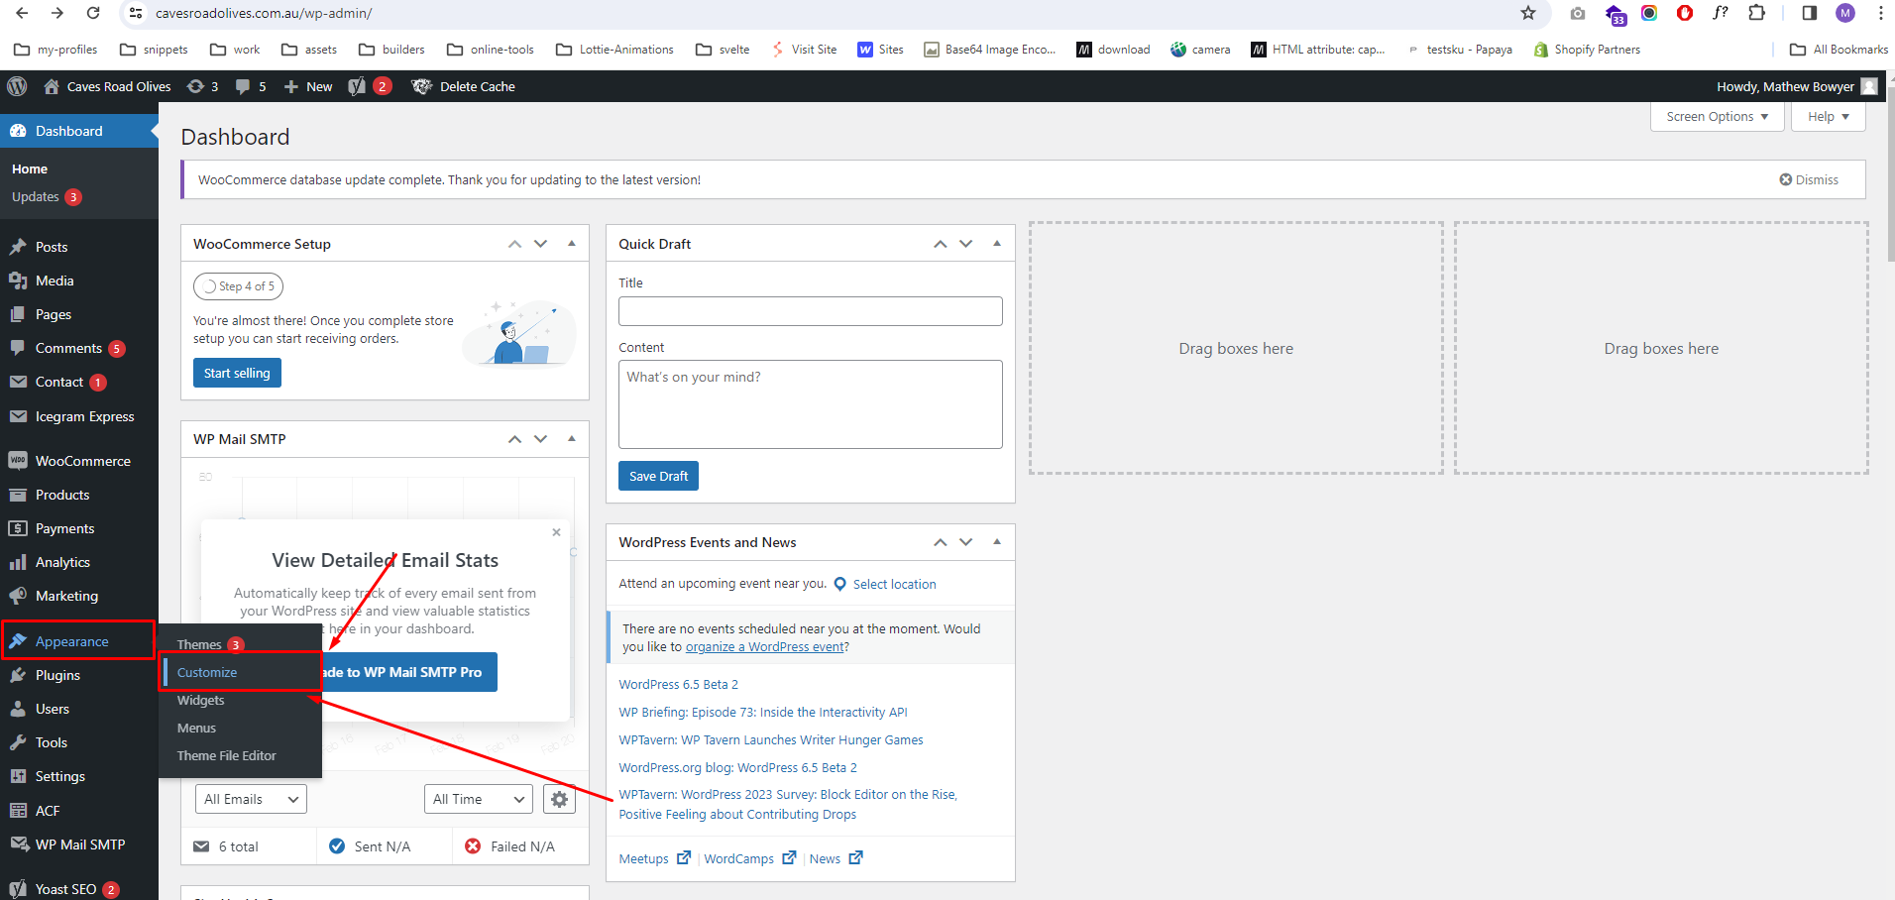

**3.)** Locate the "**Offer Popup**" customization option.

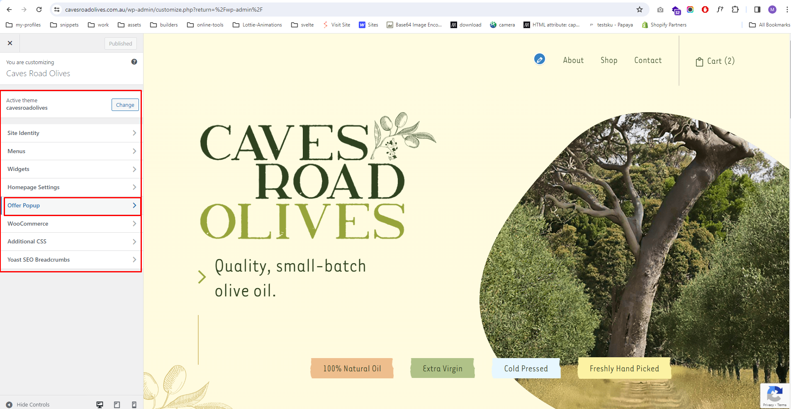

**4.)** Click on the "**Offer Popup**" option to open the customization panel.

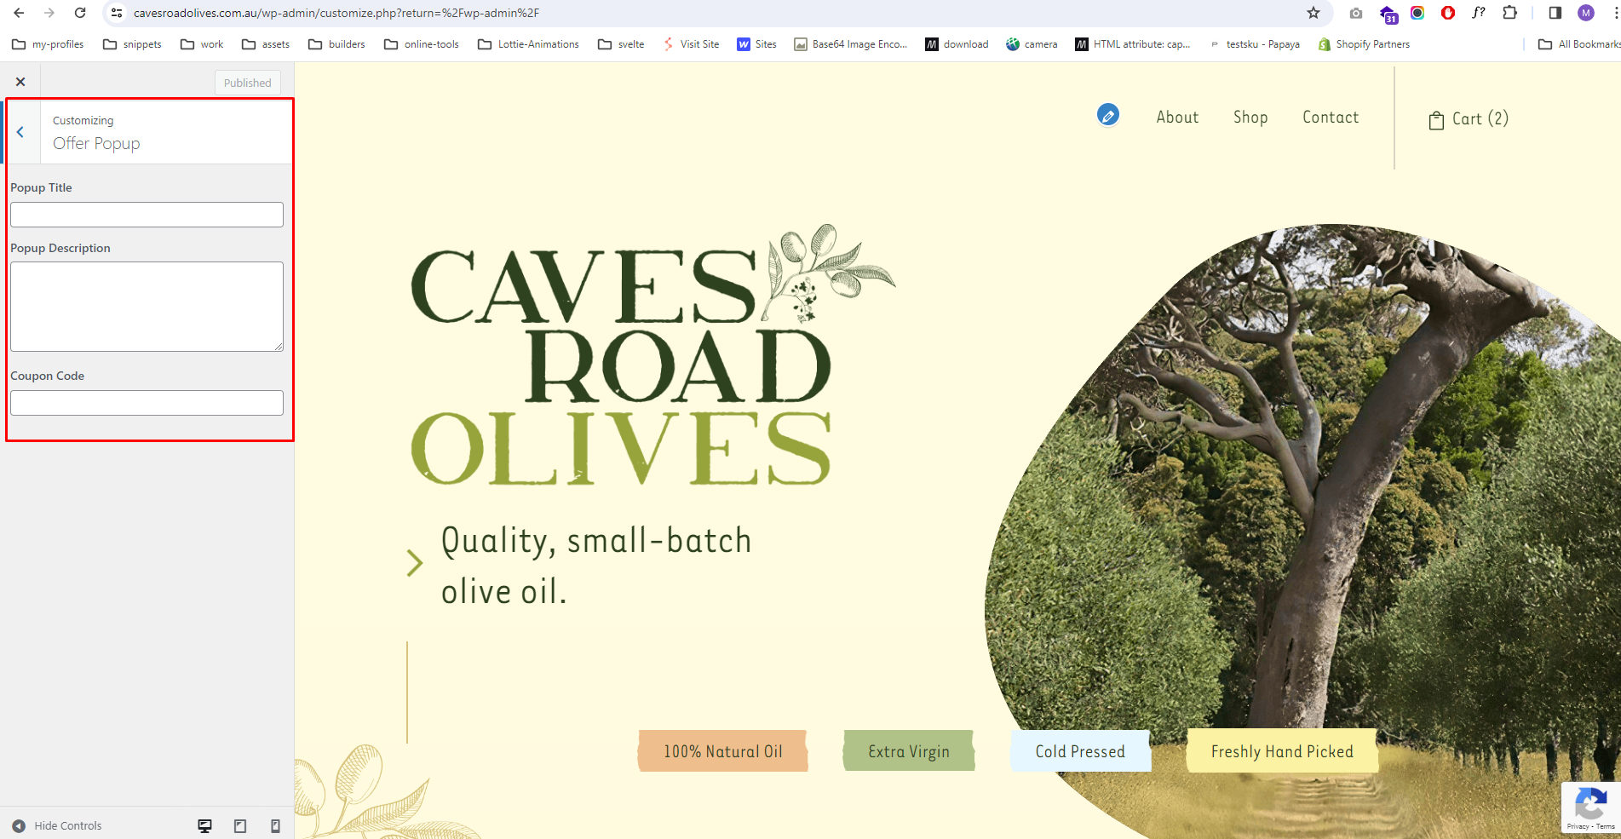

**5.)** Modify the content of the offer popup as desired.

**6.)** Save your changes.

**7.)** Test the offer popup to ensure that the updated content is displayed correctly.